PUBLIC NOTICE
Proposed Community Garden

Shellharbour City Council is considering a request from Oak Flats Community Garden Group to establish a Community Garden at the Council owned property listed in Schedule 1.

Schedule 1:

- Hippisley Park – 42 Fisher Street, Oak Flats – Lot 86 Sec C DP13638

Community gardening is a recreational activity that contributes to the health and well-being of our community as well as providing a range of environmental, social and educational benefits.

A location map and concept plan can be found in Attachments 1 & 2. Note the concept plan is not formally endorsed by Council at this stage.

Licence Agreement

The proposal suggests a phased approach. Stage 1 will be considered by Council in the first instance, with further expansion to Stage 2 being conditional upon a range of considerations such as upkeep, member numbers, and community involvement.
Council will consider a 12-month trial licence agreement to the Oak Flats Community Garden Group for Stage 1 in the first instance, to formalise the occupation of the land. The Licence Agreement will be under the CEO delegation.
On Exhibition

Relevant documentation relating to the community garden, including the concept plan and proposal document can be found on Council’s website for 14 days from the date of this publication.

Public Submissions

Submissions may be made in writing from Monday, 16 October 2023 to 5.00pm Monday, 30 October 2023 stating Council’s reference number: LIC0106/2023 and addressed to:

Chief Executive Officer
Locked Bag 155
Shellharbour City Centre, 2529

or sent by email to council@shellharbour.nsw.gov.au

Please note that under the provisions of the Government Information (Public Access) Act 2009, such submissions may be referred to third parties for consideration. Enquiries may be made through Council’s Business and Investment Team by telephoning 4221 6111

Mike Archer
Chief Executive Officer Date: 16 October 2023

Attachment 1 – Location Map

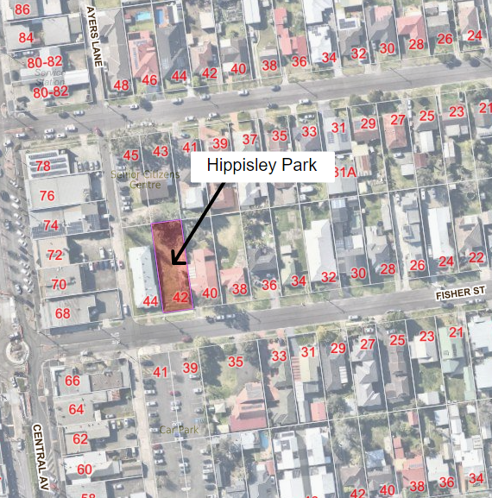

Attachment 2 – Concept Plan
